How the Telugu Newspaper Extractor Works — A Beginner's Guide

How the Telugu Newspaper Extractor Works
A beginner's guide, explained from the ground up using one real page — the Sakshi / Janagam edition with the big red “పెట్రో ఘాతం!” (Petrol Shock!) lead story.
Contents
- The big idea (in one minute)
- The problem: a page is a pile of unlabelled stories
- Stage 1 · Turn the PDF into a picture
- Stage 2 · Draw a box around every block
- Sidebar: how to read a box's coordinates
- Stage 3 · The brain — read, judge, and group (AI)
- Stage 3b · Double-check each headline (AI)
- Stage 5 · Tidy the article boundaries
- Stage 4 · Cut out each article
- Outputs, de-duplication, and limits

Start here

The big idea, in one minute
You hand the program a newspaper PDF. It hands you back a tidy folder of individual article images — but only the articles that an opposition politician could actually use. To do that it has to answer two hard questions about a page that has no labels: which pixels belong to which story, and which stories are worth keeping.
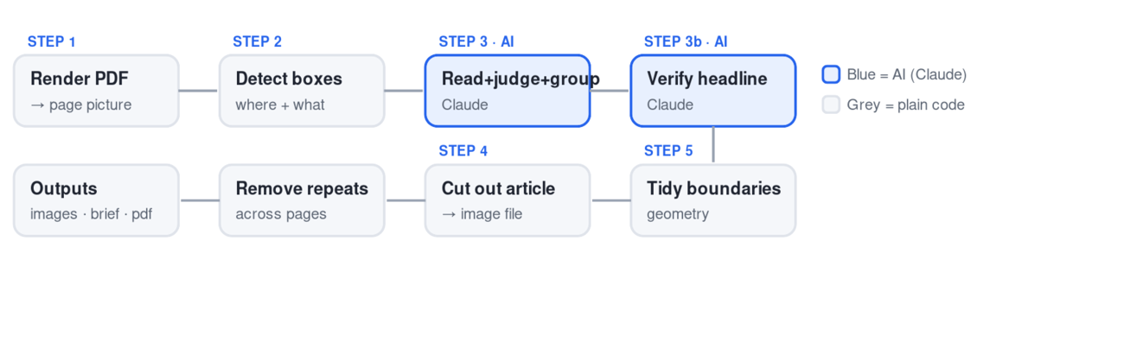
Seven steps. Only the two blue ones use AI; the rest is ordinary code working on coordinates.
Hold onto this one sentence: the computer never "understands" the newspaper as a whole. It chops the page into little boxes, asks an AI to read and group them, and then uses plain geometry to cut the groups out. Everything below is just that idea in slow motion.

The challenge

A newspaper page is a pile of unlabelled stories
Look at our example page. To your eye it's obvious that the giant red “పెట్రో ఘాతం!” headline, the bullet list beside it, the petrol-pump photo, the paragraph below, and the little price table are all one story about fuel-price hikes. And it's obvious that “ఇందిరమ్మ ఇళ్ల మంజూరు” further down is a different story.
The computer sees none of that. It gets a flat image — coloured dots — with no lines saying "story starts here, story ends there." There are no tags, no separators it can trust. So the entire pipeline exists to reconstruct the boundaries you see instantly. That reconstruction is the hard part, and it's why there are so many stages.
Analogy. Imagine a jigsaw dumped on a table with several different pictures mixed together, and no box lid to look at. Your job: sort the pieces into the right pictures, and frame only the pictures worth keeping. Each stage below is one tool for that sorting job.

Stage 1 plain code

Turn the PDF into a picture
render_pdf_pages()
inthe newspaper PDF
outone big PNG image per page
A PDF can contain selectable text, fonts and vectors, but the rest of the pipeline works on pixels, so the first thing we do is photograph each page into a large image (about 4200 pixels wide). Bigger is better here: the more pixels, the more precisely later stages can box and cut things.
Beginner trap: the program numbers pages by their order in the PDF — page 1, page 2… That is not the printed page number. Our example is printed page 7 (top-right corner), but inside its PDF it might be the 3rd or 4th file page.

Stage 2 plain code

Draw a box around every block
detect_regions()
inone page image
outa list of boxes: {id, type, position}
A layout-detection model (PaddleOCR) scans the picture and draws a rectangle around every visual block, tagging each with a type: a doc_title (a headline), text (a paragraph), image, table, or a small paragraph_title (a cross-head). On our page it would find dozens of boxes. Here is the cluster around the petrol story (the numbers are illustrative):
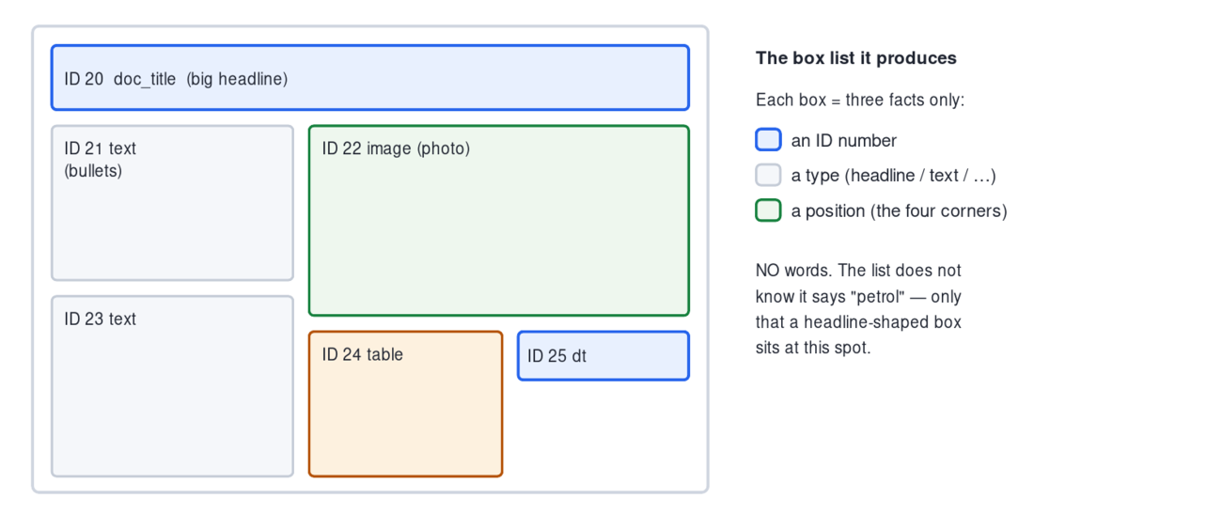
Stage 2 finds where things are and what kind they are — never what they say.
As plain text, those boxes look like this — notice there is not a single Telugu word, only IDs, types and coordinates:
ID 20: type=doc_title, bbox=[180, 980, 1180, 1180]
ID 21: type=text, bbox=[180, 1210, 760, 1620]
ID 22: type=image, bbox=[770, 1180, 1500, 1760]
ID 23: type=text, bbox=[180, 1650, 760, 2150]
ID 24: type=table, bbox=[420, 1760, 980, 1980]
ID 40: type=doc_title, bbox=[180, 2400, 980, 2470] ← a different story's headline, lower down

Sidebar

How to read a box's coordinates
That bbox=[x1, y1, x2, y2] is just two corners of a rectangle. Picture the page as graph paper: the top-left is (0, 0), going right grows the first number, going down grows the second. The box is its top-left corner and its bottom-right corner.
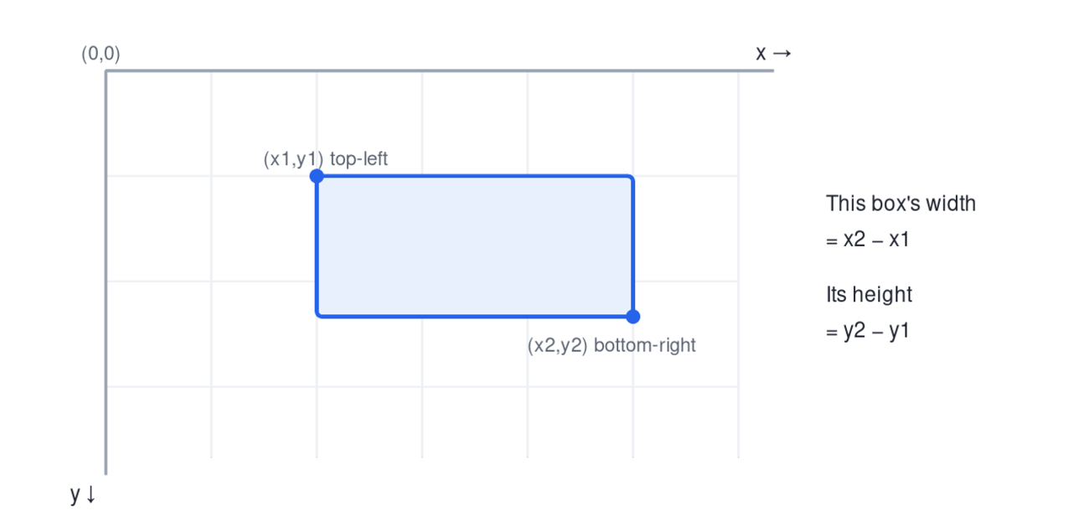
So bbox=[180, 980, 1180, 1180] is a box that is 1000 wide and only 200 tall sitting in the upper area — a wide, short shape, exactly what a big headline looks like. From four numbers, the program already knows a box's size, shape, and where it sits relative to every other box. That is the only "spatial sense" it has, and it's enough to do all the grouping later.

Stage 3 AI · Claude

The brain: read, judge, and group
identify_and_group_political_articles()
inthe page picture + the box list
outtwo lists: kept articles, and rejected ones
This is the heart of everything. It does three jobs in one go. We'll take them one at a time, all on the petrol story.

1Receive two things together
Claude is handed the picture (which it can see) and the box list (IDs, types, coordinates — no words). Neither alone is enough: the picture has words but no IDs; the list has IDs but no words. The job is to join them.

2Read the Telugu, then link it to a box ID
Claude looks at the picture and reads the big red words “పెట్రో ఘాతం!” with its own eyes. Then it asks: which box in the list sits at that spot? The answer is ID 20 (a doc_title). So it links them: "headline = box 20, and it reads పెట్రో ఘాతం."
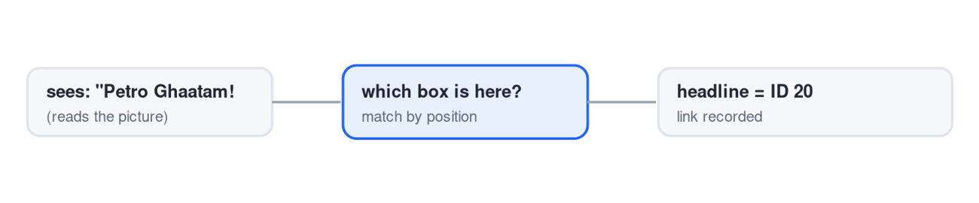
The core trick of Stage 3: spoken-words ↔ box-ID. Claude's output is always box IDs, never images.

3Judge each story with two gates
For every story it finds, Claude applies two yes/no questions. Both must be YES, or the story is thrown away. Here are real verdicts for stories on this very page:
Story on this page | Q1 — real damage, and a government to blame? | Q2 — opposition can attack? | Verdict
పెట్రో ఘాతం!  Petrol shock (price hikes) | YES — fuel taxes burden everyone | YES — blame central policy | ✅ KEEP
ధాన్యం బస్తాలకు నిప్పు పెట్టి నిరసన  Farmers burn paddy sacks in protest | YES — procurement failure hits farmers | YES — attack the state government | ✅ KEEP
టైలరింగ్ కోర్సులో శిక్షణ  Tailoring-course training (an advert) | NO — it's an advertisement, no harm | NO | ❌ REJECT
విద్యారంగాభివృద్ధికి రూ.219 కోట్లు  Rs.219 cr for education development | NO — a positive funding announcement | NO | ❌ REJECT
The key concept — "harm that already happened," not "topic." The filter is not "is this about politics." It is narrower: is there a victim and real loss, and can a government be blamed? A good-news funding story and an advert are both "political-ish" yet fail, because nobody was harmed by a government act.

4Group the boxes into one article
Now the part that took us the longest to get right. For each kept story, Claude must say which boxes belong together. The rule, in plain words:
An article = one headline + the boxes touching it (below or beside), in the same block, until the next headline.
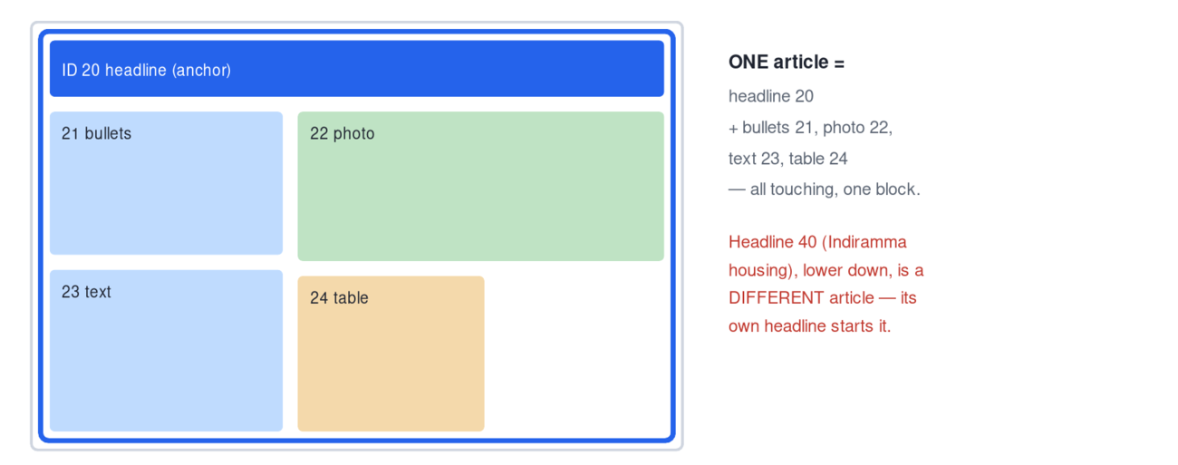
Boxes 20–24 share one block under one headline → one article. The next headline begins the next article.
Three sub-rules keep this honest, all visible on our page:
One headline = one article. The petrol headline (20) and the “ఇందిరమ్మ ఇళ్ల” headline (40) are two headlines, so they are two articles — never merged, even though they sit in the same column.
A box with no headline of its own belongs to the story around it. The price table (24) and the photo (22) have no headline; they're clearly part of the petrol story, so they fold in. The little “నెలకు అదనపు భారమే” side-panel with a person's photo is a quote-box inside the petrol story — it's folded in too, not emitted as a separate half-article.
The dateline is a "story starts here" signal. Telugu articles begin their body with a place + date, e.g. జనగామ టౌన్, మే 16 (సాక్షి):. When Claude sees a fresh dateline, it knows a new article's body is starting there.

5Return the answer as data
The reply is two lists in JSON. For the petrol story (abbreviated):
{
"political_articles": [
{
"headline_telugu": "పెట్రో ఘాతం!",
"headline_english": "Petrol shock!",
"member_region_ids": [20, 21, 22, 23, 24], ← the boxes to cut together
"q1_reason": "Fuel price hikes (central tax policy) burden people in Telangana",
"q2_reason": "Opposition can blame the central government for fuel prices",
"attack_angle": "..."
}
],
"rejected": [
{ "headline": "టైలరింగ్ కోర్సులో శిక్షణ", "reason": "advertisement — no victim" }
]
}
The single most important idea: Stage 3's output is not images and not full text. It's a mapping — "story X is made of boxes 20, 21, 22, 23, 24." The picture lets Claude read; the coordinates let it point; the grouping rules decide where one story ends and the next begins.
Why it's only a first draft. Claude reasons over a shrunk copy of the image plus a coordinate list, so its grouping is a smart guess. It can pick the wrong headline box, leave out a paragraph, or bundle two stories. Stages 3b and 5 exist to catch and repair exactly those slips before anything is cut.

Stage 3b AI · Claude

Double-check each headline
verify_headlines_with_claude()
For each kept story, the program crops just the headline box Claude pointed at, asks Claude to re-read it, and compares that to the headline Claude originally claimed. The result picks one of five outcomes:
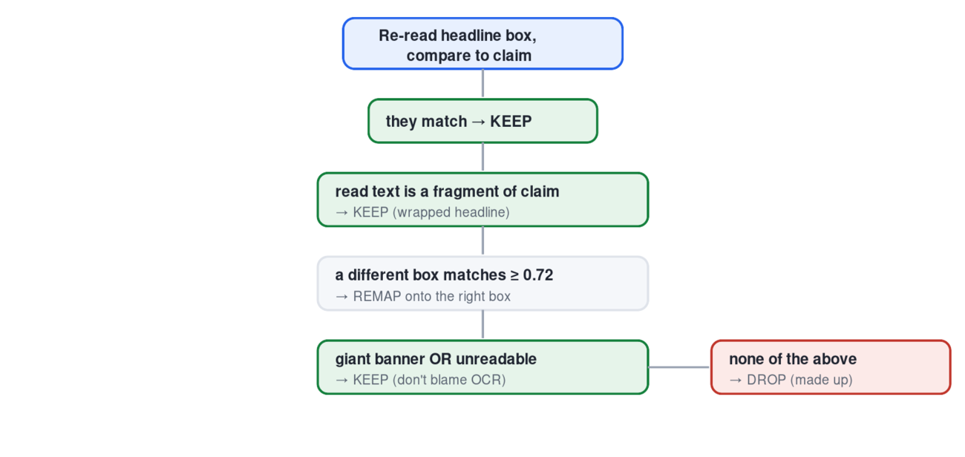
Checks run top to bottom; the first that fits decides. Green = keep, red = drop.
Why it matters (real bugs we fixed here). A huge stylised banner can defeat re-reading — so banners are kept, not dropped, which stopped lead stories vanishing. And the "fragment" and 0.72 rules stop a correct story being moved onto the wrong headline just because two Telugu titles share the common “…ించాలి” (“must/should”) ending.

Stage 5 plain code

Tidy the article boundaries
split_disjoint_articles()
No AI here — just geometry that fixes Claude's draft grouping. It runs a few passes, each repairing one kind of mistake, always keeping the headline as the anchor.
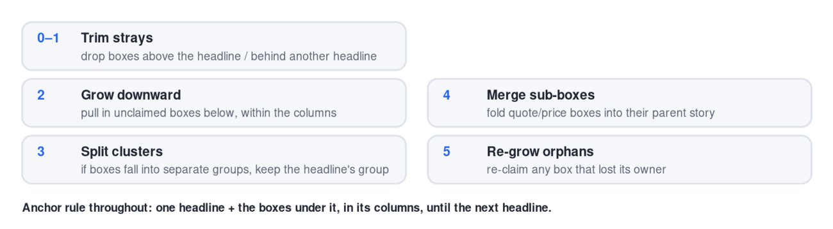
Real bug fixed here. Pass 5 (re-grow) is new: it rescues a paragraph that got mis-assigned to a neighbour and then stranded — the cause of a crop that was only a headline with no body.

Stage 4 plain code

Cut out each article
crop_political_articles()
Now it's pure scissors. For each article, take the boxes (20–24 for petrol) and draw one rectangle that just contains them all: the left edge is the smallest x, the top the smallest y, the right the largest x, the bottom the largest y, plus a small margin. That rectangle is the article boundary. Crop the page image to it — that's your article.png.
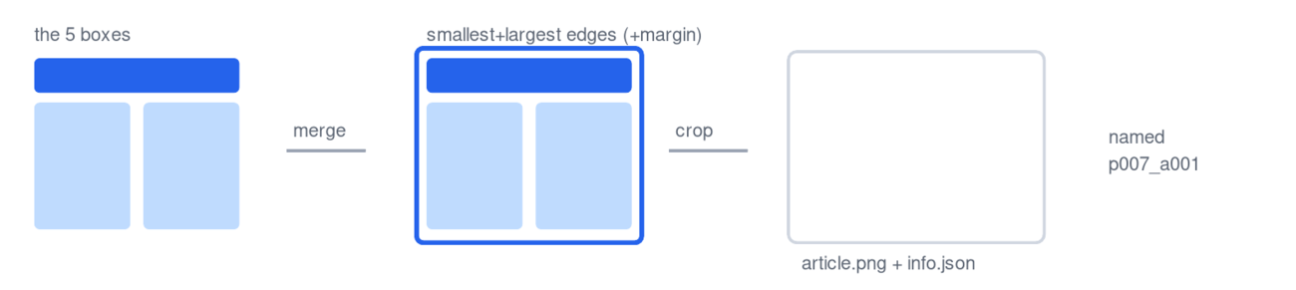
It also saves an info.json next to each crop (the headline, the box IDs, the reasons), and stamps the page number and crop size for the next step.

Final stage plain code

Outputs, de-duplication, and limits
After every page is cut, the program removes duplicates — a big story can run on the front page and in full inside, so it keeps only the largest (most complete) crop of each headline and deletes the rest. Then it writes three deliverables:
political_articles.jsonthe final list of articles (data)
opposition_daily_brief.txtheadline + WHY + ATTACK, grouped by priority
political_articles.pdfall the crops in one PDF

Where to look when something is wrong
For any page, three files in output/<run>/pages/ tell the whole story: page_00X.regions.json (what Stage 2 detected), page_00X.political_result.json (what survived Stages 3–5), and page_00X_political_debug.png (the boxes drawn on the page). Comparing those three shows you exactly which stage made a mistake.

Honest limits
Stage 3's reading and judging is an AI guess, so it isn't perfectly repeatable — the same borderline story can be kept on one run and dropped on another. And the geometry constants (gaps, margins) are tuned to these papers at this image size. The program works well for Sakshi and Andhra Jyothi as set up; pointing it at a very different paper would need its thresholds re-tuned and its political framing adjusted.
A beginner's guide to smart_extractor.py · worked through the Sakshi / Janagam “పెట్రో ఘాతం!” page.

