How smart_extractor.py works

How smart_extractor.py works
A stage-by-stage guide to turning a Telugu newspaper PDF into a set of cropped, opposition-relevant article images. Each stage is one function in the file; the diagrams show what goes in, what happens, and what comes out.
The pipeline
- Big picture — the whole flow
- Stage 1 · Render the PDF into page images
- Stage 2 · Detect layout boxes
- Stage 3 · Classify & group into articles (AI)
- Stage 3b · Verify each headline (AI)
- Stage 5 · Tidy the boundaries (geometry)
- Stage 4 · Crop each article
- Outputs & cross-page de-dup

Orientation

The whole flow at a glance
The conductor is main(). It renders every PDF page, then runs each page through the same chain of stages, and finally writes the outputs. Only two stages use AI (Claude); everything else is deterministic code working on box coordinates.
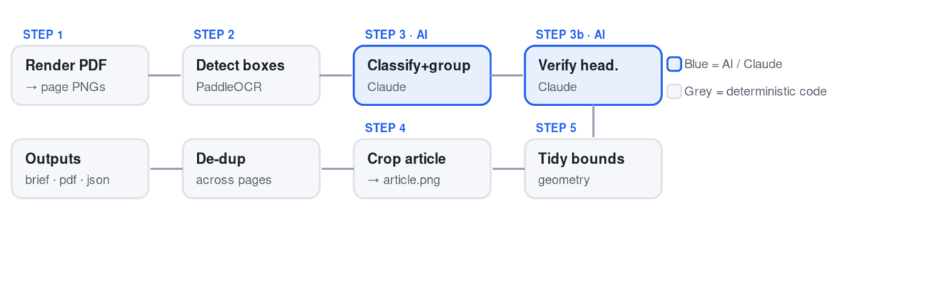
One PDF in, a folder of article crops + a brief out. Steps repeat per page; de-dup and outputs run once at the end.
The one idea to hold onto: only "which boxes are an article" (Step 3) and "is this the right headline" (Step 3b) are AI judgments. Detection, cleanup, cropping and de-dup are plain geometry. That's why bugs split into two kinds — geometry bugs (wrong-sized crop) are code fixes; flaky bugs (article vanishing, wrong region) trace back to the AI/OCR steps.

Stage 1 deterministic

Render the PDF into page images
render_pdf_pages(pdf_path, pages_dir, target_w=4200, target_h=7400)
ina PDF file
outone big PNG per page (page_001.png …)
It opens the PDF with PyMuPDF (fitz) and walks each page. For every page it works out how much to enlarge it: scale = min(target_w/width, target_h/height). Taking the smaller of the two ratios means the page fits inside a 4200×7400 box without stretching — the aspect ratio is preserved. It renders at that scale and saves the PNG.
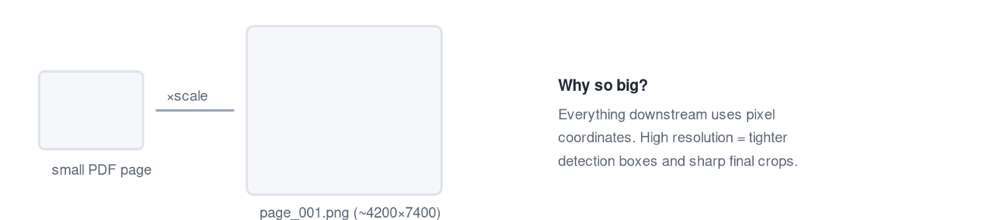
Gotcha: the page number here (001, 002…) is just the order inside the PDF — not the printed page/folio. A 4-page PDF can hold printed pages 1, 7 and 8.

Stage 2 deterministic

Detect layout boxes
detect_regions(page_png_path)
inone page PNG
outa list of regions: {id, type, bbox, confidence}
It runs PaddleOCR's LayoutDetection model, which draws a box around every visual block and labels what kind it is. The function tidies the model's output into clean dictionaries. Crucially, this stage finds where things are and what kind they are — it does not read the Telugu text yet. These boxes are the atoms every later stage works with.
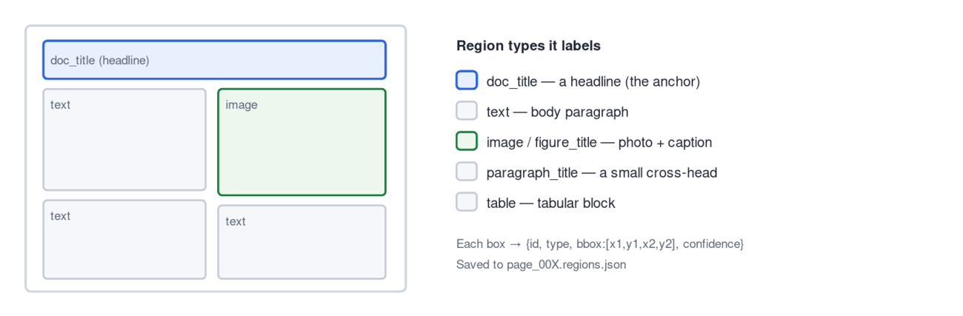

Stage 3 AI · Claude

Classify & group into articles
identify_and_group_political_articles(page_img_path, regions, page_num)
inthe page image + the region list
outJSON: political_articles[] + rejected[]
This is where meaning enters. The page image is shrunk to 1500px wide and JPEG-encoded, the regions are written out as a text list (ID 42: type=doc_title, bbox=[…]), and both are sent to Claude with the POLITICAL_PROMPT. The prompt casts Claude as an opposition strategist and makes it apply two gates to every story.
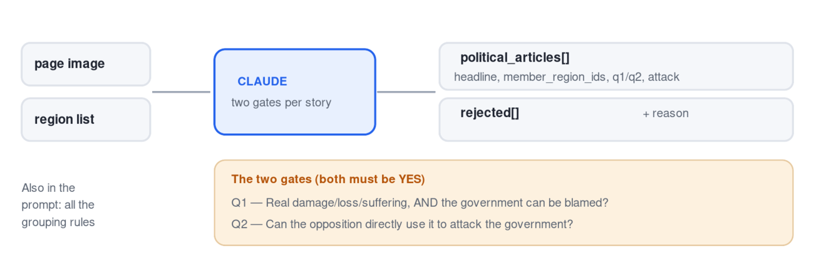
Claude returns, for every kept story, the Telugu & English headline, the member_region_ids that form it, and the q1/q2/attack reasoning — plus a rejected list with reasons. This single call does both jobs: deciding what's political and grouping the boxes.

① What Claude actually receives
Two things together: the page picture, and a plain-text list of the boxes from Stage 2. The list is just IDs, types and coordinates — no text. Claude's job is to look at the picture, read the Telugu with its own eyes, and tie what it reads back to the box IDs in the list. Here's a slice of that list for the top of a real page:
# the region list (a fragment) — this is the text Claude gets alongside the image
ID 57: type=doc_title, bbox=[1276, 270, 3065, 419] ← a headline
ID 66: type=paragraph_title, bbox=[1302, 455, 2097, 501]
ID 13: type=text, bbox=[1264, 513, 2134, 1251] ← body paragraph
ID 17: type=image, bbox=[2147, 445, 3072, 962] ← photo
ID 94: type=figure_title, bbox=[2212, 977, 3065, 1029] ← photo caption
ID 44: type=doc_title, bbox=[2680, 4518, 4032, 4628] ← a different headline, far down the page
Concept — coordinates are the shared language. Claude can't hand you a cropped image; it can only say "these ID numbers go together." Every later stage then uses those IDs' coordinates to do the actual cutting. So Stage 3's real output is a mapping: story → list of box IDs.

② The two gates, with real examples
Every story on the page is tested against both questions. Both must be YES to keep it. These rows are actual decisions from your runs:
Headline | Q1 — real damage + government to blame? | Q2 — opposition can attack? | Verdict
బంగారంపై రుణం.. ఇక భారమే!  Gold loans now a burden | YES — new RBI rules squeeze middle-class borrowers | YES — blame the central government | ✅ KEEP
దిగుమతులు లేక నిలిచిపోయిన ట్రాక్టర్లు  Tractors stranded at procurement | YES — state procurement failed, farmers lose money | YES — attack the state government | ✅ KEEP
వంట గ్యాస్ కొరతను నివారించాలి  Cooking gas shortage | YES — LPG supply failure, people block a highway | YES — blame central gas policy | ✅ KEEP
ఆరోగ్యంపై ప్రత్యేక దృష్టి సారించాలి  Judge's advice: focus on health | NO — no victim, no damage; just advice | NO — no attack angle | ❌ REJECT
అంబులెన్స్‌పై కూలిన భారీ వృక్షం  Tree fell on an ambulance | NO — a natural event, no government role | — | ❌ REJECT
మహిళా బిల్లును ఆమోదించాలి  Pass the women's bill | NO — a demand, not a damage event that already happened | — | ❌ REJECT
Concept — "damage that already happened," not "topic." The filter isn't "is this about politics." It's narrower: is there a victim and real loss, and can a government be blamed, such that the opposition can use it? A health speech, a natural accident, or a policy demand are all "political topics" yet fail, because nobody was harmed by a government act.

③ Grouping — which boxes form one article
Classifying is only half the call. Claude must also say which boxes belong to each kept story. The rule it's told to follow: a headline (doc_title) is the anchor, and its article is the boxes touching it — the body text, photo and caption directly under or beside it — up to the next headline.
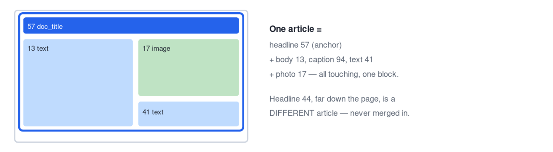
Three sub-rules keep the grouping honest: a region whose text starts with a dateline (వరంగల్, మే 14 (ఆంధ్రజ్యోతి):) marks the start of an article's body; two different datelines side by side mean two different stories; and a small quote-box or testimonial with no headline of its own is folded into its parent article rather than emitted separately.

④ What comes back
The reply is JSON — two lists. Abbreviated, for the gold-loan story:
{
"political_articles": [
{
"headline_telugu": "బంగారంపై రుణం.. ఇక భారమే!",
"headline_english": "Gold loans.. now a burden!",
"member_region_ids": [54, 4, 30, 16, 13], ← the boxes to crop together
"q1_reason": "New RBI norms squeeze middle-class borrowers...",
"q2_reason": "Opposition can blame central govt / RBI...",
"attack_angle":"Modi government's gold-loan rules crush the middle class...",
"priority": "medium", "category": "public_grievance"
}
],
"rejected": [
{ "headline": "ఆరోగ్యంపై ప్రత్యేక దృష్టి సారించాలి",
"reason": "Judge's health advice — no victim / attack angle" }
]
}

⑤ Why this is only a first draft
Claude is reasoning over a shrunk image (1500px wide) and a list of coordinates — not the full-resolution page. So its grouping is a smart guess, and three kinds of error show up, each of which a later stage repairs:
First-draft slip | Real case | Fixed by
Picks the wrong headline box | cooking-gas anchor mis-read | Stage 3b (verify / remap)
Leaves out body paragraphs | gold-loan kept only its headline | Stage 5 (grow / re-grow)
Bundles two stories together | — | Stage 5 (split)
Takeaway: Stage 3 decides meaning — what's worth keeping and roughly which boxes go together. It is deliberately not trusted to be pixel-perfect; Stages 3b and 5 exist to verify and clean up its draft before anything gets cropped.

Stage 3b AI · Claude

Verify each headline
verify_headlines_with_claude(political_articles, regions, page_img_path, min_similarity=0.40)
inthe draft articles
outthe same list, with bad picks fixed or dropped
For each article it crops just the headline box Claude pointed at and asks Claude to read the actual Telugu, then compares that to the headline Claude originally claimed (using a character-similarity score). The outcome decides the article's fate:
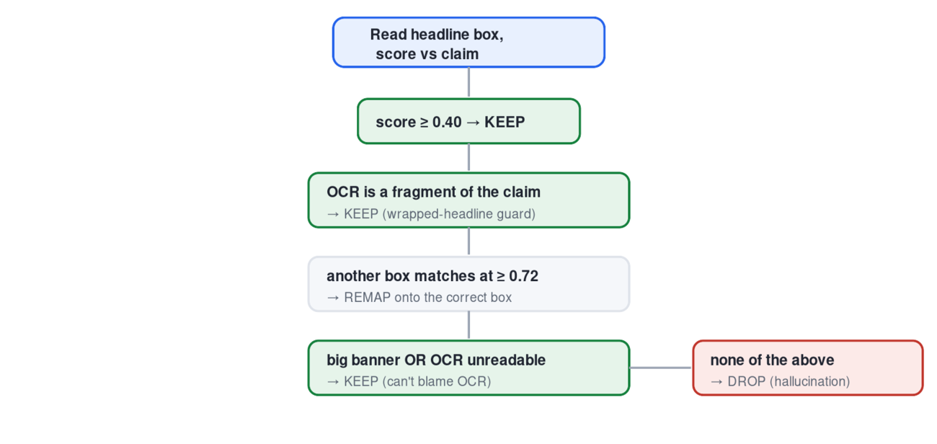
The checks run top to bottom; the first one that fits decides. KEEP paths are green, DROP is red.
What we fixed here. The big-banner KEEP stops legit lead stories vanishing when OCR can't read giant stylised type. The fragment guard + the raised 0.72 remap bar stop a correct article being relocated onto a different headline just because two Telugu titles share the common “…‍ించాలి” (“must/should”) ending — the cooking-gas/health mix-up.

Stage 5 deterministic

Tidy the boundaries
split_disjoint_articles(political_articles, regions, gap=60)
inverified articles (headline + a rough set of boxes)
outarticles whose boxes are clean, complete and non-overlapping
Pure geometry, no AI. It runs the draft through a series of passes that each fix one kind of grouping error. The headline is always the anchor; the rules decide which surrounding boxes truly belong to it.
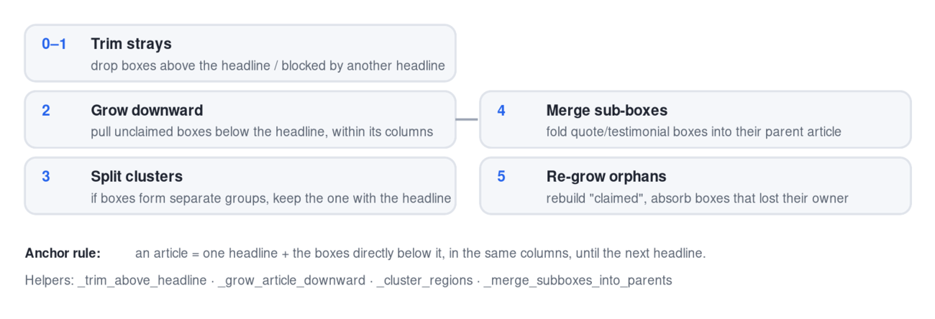
What we fixed here. Pass 5 (re-grow) is new. The original growth in Pass 2 used a "claimed" list built before the split, so when a body paragraph got mis-assigned to a neighbour it became stranded. Pass 5 rebuilds that list afterwards and hands the orphan back to the right article — this is what fixed the gold-loan crop that was only its headline.

Stage 4 deterministic

Crop each article
crop_political_articles(page_img_path, political_articles, regions, output_dir, page_num)
inclean articles (a headline + its body boxes)
outone article.png + info.json per article
For each article it takes the bounding boxes of all member regions and merges them into one rectangle — the left/top is the minimum of all the box edges, the right/bottom the maximum, with a 15px margin. That rectangle is the article boundary; it crops the page image to it and saves the result, plus an info.json describing the article.
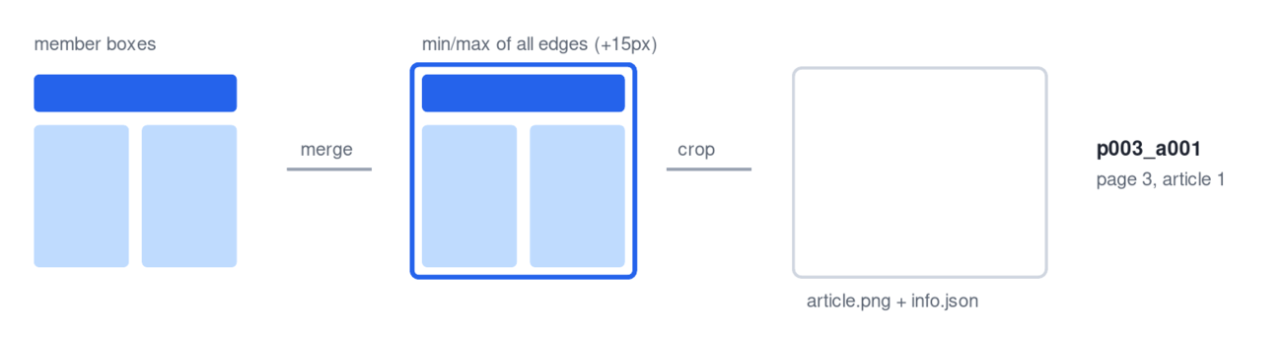
It also stamps each article with its page number and crop area — those are used by the de-dup step next.

Final stage deterministic

Cross-page de-dup & outputs
main() → de-dup · generate_brief · generate_pdf · copy_all_images
After all pages are cropped, main() removes duplicates: a story can run on two pages (a front-page lead and the full inside article). It groups articles by their normalised Telugu headline and keeps only the one with the largest crop — the most complete version — deleting the others' crop folders. Then it writes the three deliverables.
political_articles.jsonthe final article list (data)
opposition_daily_brief.txtHIGH/MEDIUM grouped, headline + WHY + ATTACK
political_articles.pdfevery crop compiled into one PDF
What we fixed here. De-dup now also deletes the dropped duplicate's crop folder, so the articles/ directory matches the real outputs — no more gold-loan showing up twice when you browse the folders.

Where to look when something's wrong. For any page, open the three files in output/<run>/pages/: page_00X.regions.json (what was detected), page_00X.political_result.json (what survived), and page_00X_political_debug.png (the boxes drawn on the page). Comparing those three tells you which stage made the mistake.
Generated for the Telugu newspaper extractor · describes smart_extractor.py

